Group Members:
Abdul Muqeet Shahzad Daniyal Aqram Talha Group IDs:
F2023332001 F2023332028

System architecture diagram
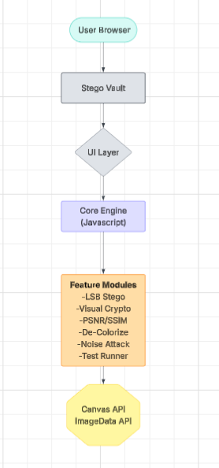

Data Flow Diagram
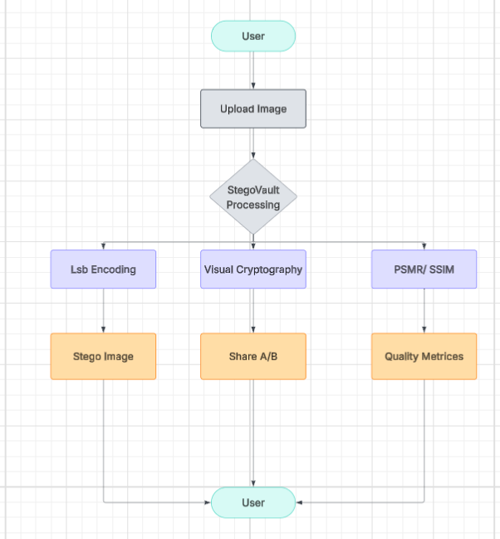

Threat Model:

Threat Category | Description | Risk Level | Mitigation
Data Leakage | Hidden message or image exposed | Low | Everything stays in browser memory. No network requests.
Malicious Input | User uploads harmful file | Low | Browser sandbox + file type validation (image/*)
Cross-Site Scripting | Code injection via inputs | Very Low | No server rendering; all logic is static JS
Denial of Service | Very large image crashes browser | Medium | Image resizing logic + practical size limits

Reverse Engineering | Someone inspects the JS code | Medium | Tool is open educational prototype (intentional transparency)
Persistent Storage | Sensitive data remains after closing tab | Low | All data is temporary; cleared on page refresh

Technology Justification

Technology | Justification | Why Not Alternatives
HTML5 + CSS3 | Modern, responsive UI with excellent visual design and animations | Heavy frameworks (React/Vue) — overkill for this scope
Vanilla JavaScript | Full control over Canvas API and ImageData for pixel manipulation | Python/Flask — would require backend hosting and reduce accessibility
Canvas API | Native browser support for fast image processing and drawing | Server-side libs (Pillow, OpenCV) — breaks "no installation" goal
FileReader API | Secure way to read local files without uploading | Server upload — unnecessary and less private
No External Libraries | Zero dependencies — tool works offline after loading | jQuery, Bootstrap — adds bloat
Single HTML File | Easy to share, host, or run locally (just open in browser) | Multi-file project — harder to distribute

